Finding Courses with the Experiential Learning (EL) Tag
There are a variety of ways to fulfill the EL requirement. These include taking a course which has an EL designation, registering for Exp 250 with the Service Learning Program, registering for an internship, taking a Study Away course, and more.
Below find directions for locating courses on BlueNet which carry the EL designation, and which fulfill the EL requirement for graduation. Many of the courses are particular to specific majors, but some are open to all majors.
Here are some courses listed that include Service Learning and are open to all students:
REL 230 Christian Social Ethics
REL 350 Religion in America
POL 401 Feminist Theory
POL 402 Political Justice
Here are some Study Abroad courses that are open to all students and include Service Learning:
EC History of Play, Sport and Pedagogy in Ancient Greece
EC South Africa: Service and Interdisciplinary Study

- Log into the Elmhurst Portal and click on BlueNet Services.
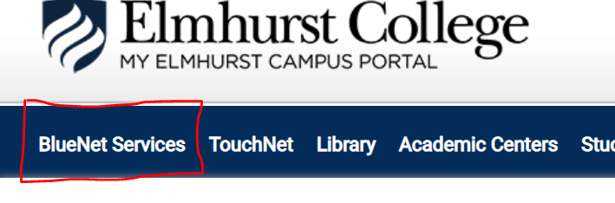

- Then, click on Search for Classes to the left hand side of your screen.
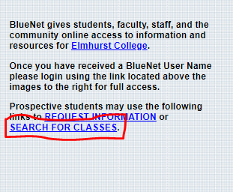

- Next, choose a term on the drop down for Term.
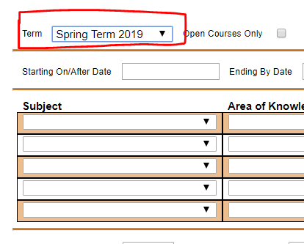

- Lastly, click on the drop down menu for Course Type and select Experiential Learning. Click submit to list all the courses with an Experiential Learning tag that are offered that term.
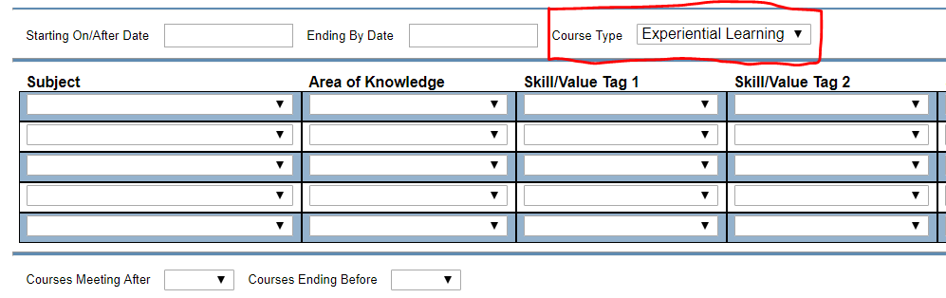

Learn. Serve. Engage.
Email: service.learning@elmhurst.edu
Instagram: @elmhurstservicelearning
Facebook: @elmhurstservicelearning

