How to access guest tickets:
- Login to Marching order and click on “Register Here”, even if you have already registered.
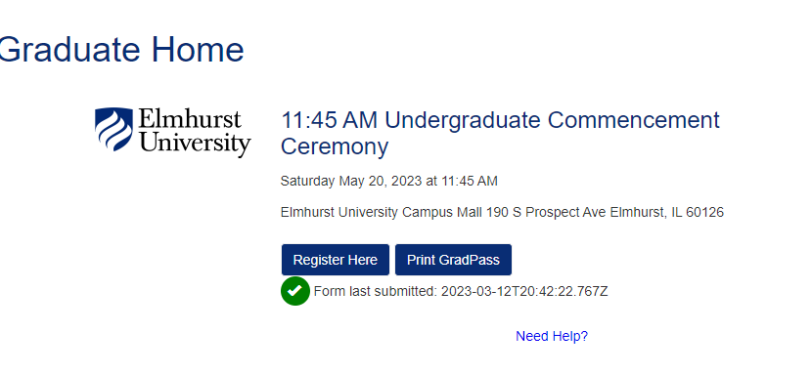
- Make sure you selected “Yes” to the question, “Do you plan on participating in the Ceremony”.
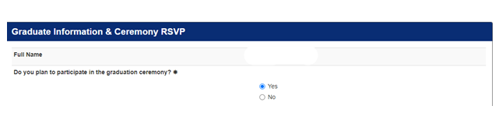
- Scroll down to bottom of the registration form, to the section titled “Your Tickets”.
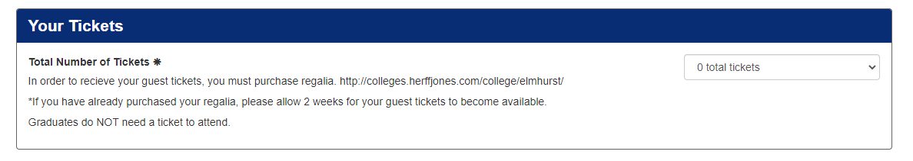
- Then, click on the drop down, that is where you will select “6 total tickets” for your guest tickets.
